**Day 5**

**Opened Wireshark**

**Choose eth0 interface**



**Generated Traffic**

**Filtered Packets**

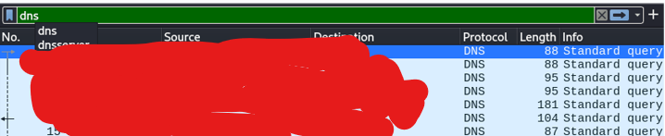



**Various Protocols Found**

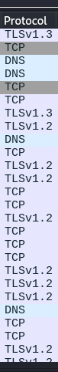

**Saved a .pcap file**

